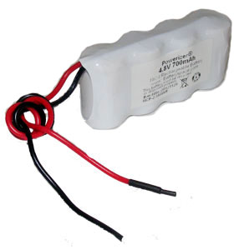

* 4.8V 700 mAh NiCd battery pack made of 4 x 2/3A [NiCd cells](http://www.batteryspace.com/index.asp?PageAction=VIEWPROD&ProdID=569).
* Rapid charging at 0.7 A Max.
* Max. Discharging rate:  1.4 Amp
* Dimension:  2.69" (L) x 1.12" (w) x 0.67" (h)
* Weight: 3oz / 80g
* 4" length 22 AWG prewired
* Please choose our [7.25 V 500mA DC Power Supply](http://www.batteryspace.com/index.asp?PageAction=VIEWPROD&ProdID=2290) + [the connector adaptor](http://www.batteryspace.com/index.asp?PageAction=VIEWPROD&ProdID=2303)to recharge the battery pack.
  + The charging time is about 1.4 hours
* Replace emergency light battery for
  + Emergi-lite  850.0062

Link to Dealer: http://www.batteryspace.com/nicdbatterypack48v700mah4x23awithwire.aspx